Experiment 16: Changing Hardware Compatibility of a Virtual Machine
Aim
To change the hardware compatibility of an existing Virtual Machine using cloning or reconfiguration.
Steps
Method 1: Using Clone
- Power off the existing VM.
- Clone the VM.
- While cloning, modify hardware settings (CPU, RAM).
- Save and start the cloned VM.
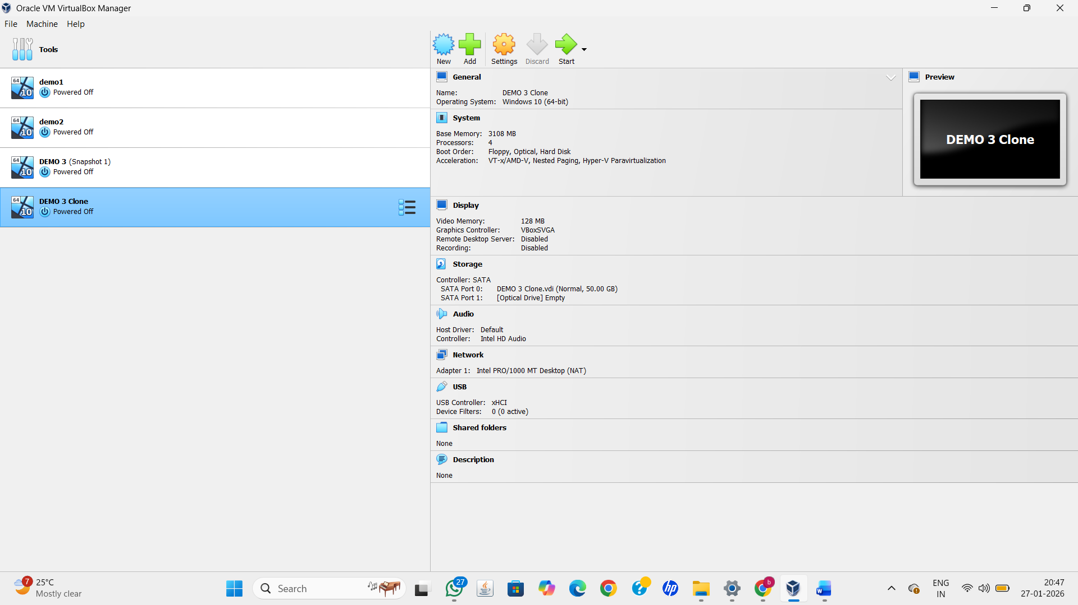

Method 2: Direct Configuration
- Power off the VM.
- Go to Settings → System.
- Modify CPU count, RAM size, or chipset.
- Save and start the VM.
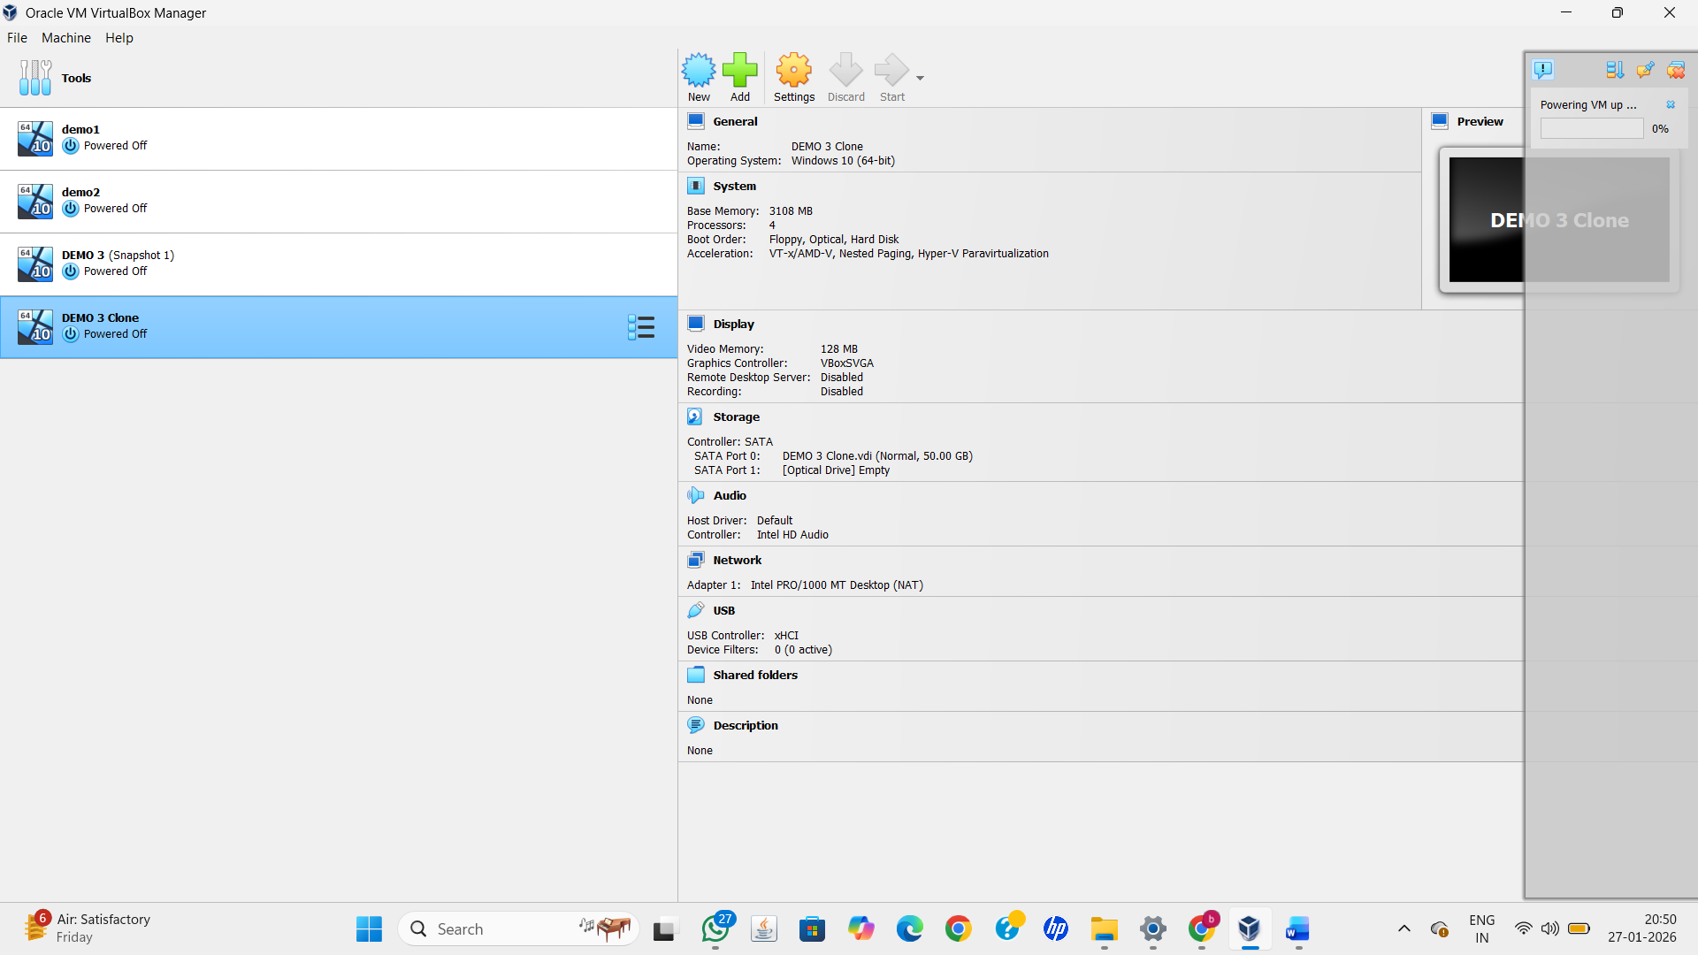
Result
Hardware compatibility of the Virtual Machine was successfully modified and verified.

